**DigiMesh DemoService REST Service 結果展示**

1. 連線位置 :

* Rest Service : <http://10.1.1.1:12805/apicommon> (POSTMAN測試為例)

1. 結果展示 :

**Rest Service (POSTMAN測試為例)**

Request Header:

Content-Type : application/json

Accept : text/plain

Request Json:

|  |
| --- |
| {  "amheader" : {  "ChannelID" : "ESB",  "ServiceDomain" : "DemoService",  "OperationName" : "OneToOne",  "ConsumerID" : "TWESB",  "TransactionID" : "T1222222",  "RqTimestamp" : "2015-12-06T12:01:01.00+08:00"  },  "ambody" : {  "OneToOneRq" : {  "ServiceHeader" : {  "TxnId" : "DO01",  "TxnNo" : "DO010001"  },  "Signon" : {  "CustId" : "ESBUSER",  "CustPswd" : "123456"  },  "ServiceBody" : {  "RqTransform" : {  "Pass" : "Y",  "ErrorCode" : "0903"  },  "InterfaceProxy" : {  "Pass" : "Y",  "ErrorCode" : "0903",  "TimeOut" : "5000"  },  "RsTransform" : {  "Pass" : "Y",  "ErrorCode" : "0903"  }  }  }  }  } |

Response Json :

|  |
| --- |
| {  "amheader": {  "ChannelID": "ESB",  "ServiceDomain": "DemoService",  "OperationName": "OneToOne",  "ConsumerID": "TWESB",  "TransactionID": "T1222222",  "TrackingID": "2593919f-43f9-4120-b44e-3cf41b4ef76f",  "UUID": "3f7156ae-6c79-428e-8849-b1b24d8224c6XgdQWFZaAAhd",  "RqTimestamp": "2015-12-06T12:01:01+08:00",  "RsTimestamp": "2020-01-10T19:46:12.504+08:00"  },  "ambody": {  "OneToOneRs": {  "ServiceHeader": {  "TxnId": "DO01",  "TxnNo": "DO010001",  "SvcVer": "v1.1"  },  "Signon": {  "CustId": "ESBUSER",  "CustPswd": 123456  },  "ServiceBody": {  "RtrnCode": "00",  "RtrnDesc": "Success"  }  }  }  } |

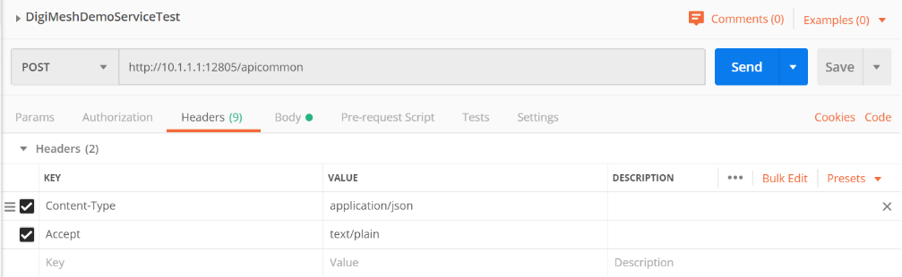

*Rest Service連線圖例 (Header設置)*

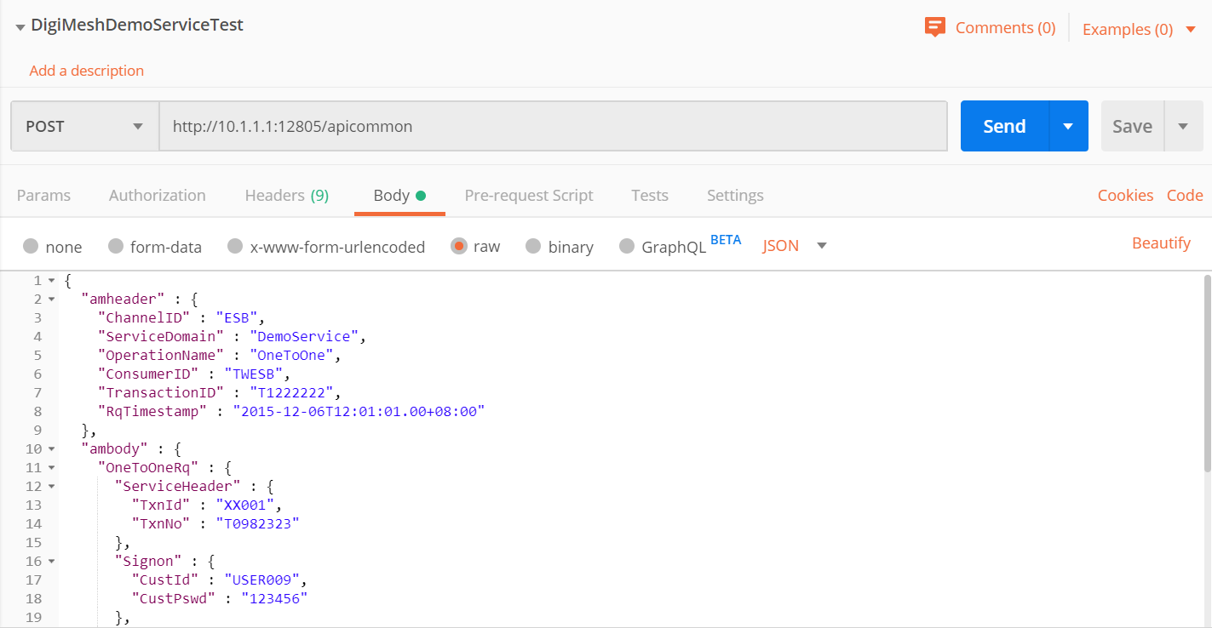

*Rest Service連線圖例 (Request Json)*

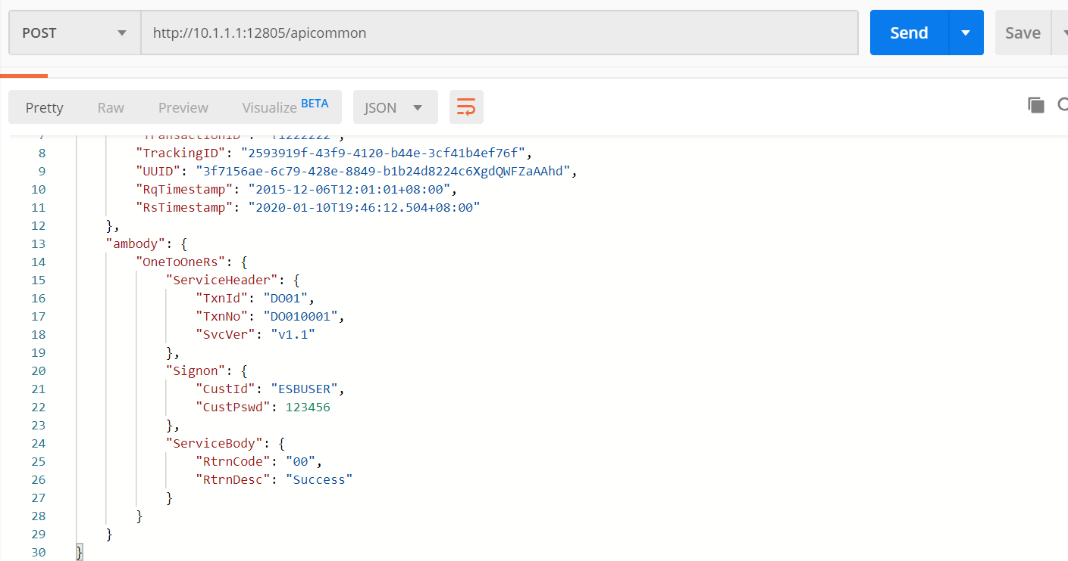

*Rest Service連線圖例 (Response Json)*